# F. Y. B. Tech Academic Year 2021-22

**Subject:** Basics of Electrical and Electronics Engineering **Trimester: 2**

**Name:** Shreerang Mhatre **Division: 11**

**Roll No:** 111056  **Batch: K3**

**Experiment No: 3**

**Name of the Experiment**: Design of voltage regulator using Zener diode.

## Performed on: 24/12/2021

**Submitted on: 31/12/2021**

**Aim: Design of voltage regulator using zener diode**.

**Prerequisite:**

* Forward biasing and reverse biasing of Zener diode
* Zener diode characteristics
* Concept of Zener breakdown and breakdown voltage

# Objectives:

* To study Zener diode as voltage regulator
* To calculate percentage line regulation
* To calculate percentage load regulation

# Components and equipment required:

## Sr.No. Name Quantity

1. Bread board 1 (One) No.
2. Zener Diode 1 (One) No.
3. Resistor (1K /2.2 K ) 1 (One) No.
4. Potentiometer 1 (One) No.

**Equipment:** Power Supply, Multimeter, Connecting wires, etc.

# Theory:

Clarence Zener is the scientist who discovered this electrical property and the device is named after him. Zener diode is a P-N junction diode specially designed to operate in the reverse biased mode. It acts as a rectifier diode when forward biased. When

reverse biased, it has a particular voltage known as breakdown voltage at which large current

flows through the diode. For rectifier diodes the value of reverse breakdown voltage is larger than that of Zener diode. Zener diodes are specially designed to operate in the reverse breakdown region. When the diode is heavily doped, its depletion region is narrow. When high reverse voltage is applied across the junction, there will be very strong electric field at the junction, and the electron hole pair generation takes place. Thus heavy current flows. This is known as Zener breakdown. Characteristics of Zener diode in reverse biased mode are given in Fig. 3.1.In reverse biased mode, after the breakdown of junction, current through diode increases sharply. But the voltage across it remains almost constant as shown in the Fig. 3.1. This principle is used in voltage regulator using Zener diodes. Fig. 3.2 shows the Zener voltage regulator which consists of a current limiting resistor *RS* connected in series with the input voltage *Vs* and Zener diode *D1* connected in parallel with the load *RL* in reverse biased condition. The output voltage Vz is the breakdown voltage of the diode.

The input source current *IS* is given by

The drop across the series resistance *Rs* is given by And the current flowing through it *Is* is given by From Eq. (3.1) and (3.2), we get,

(3.1)

(3.2)

(3.3)

(3.4)

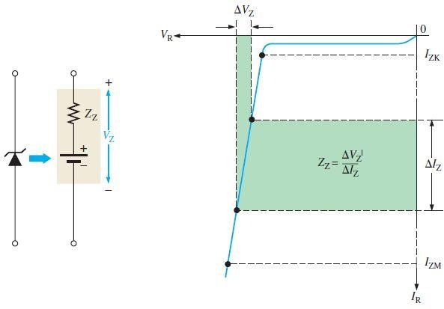

## Fig 3.1 Reverse characteristics of Zener Diode

There are two breakdown mechanisms:

### Zener Breakdown

* + ***Avalanche Breakdown***

o ***Zener Breakdown or Zener Effect:***

Zener Breakdown is a type of electrical breakdown mechanism occurs in reverse biased P-N Junctions. This breakdown occurs due to the high electric field density across the depletion region breaks some of the covalent bonds leading to large number of minority

carriers.

Zener

effect



is predominant up

to 5.6 V

negative temperature coefficient.

### o Avalanche Breakdown or Avalanche Effect:

for silicon diodes and has

Avalanche breakdown is distinct from zener breakdown. It is caused due to collision. A minority carrier in the depletion region gets accelerated by the reverse biased electric field. This may make energy of minority carriers sufficient to release electron hole pairs from covalent bonds through collision. **Avalanche effect is predominant above 5.6 V** for silicon diodes and has positive temperature coefficient.

Thus in a 5.6 V zener diode both zener and avalanche effects are equally predominant thus its positive and negative temperature dependency cancels each other. Thus naturally 5.6 V zener diode is the component of choice in temperature critical applications. Zener Diode is commonly used for making reference voltages for Voltage Regulators and to protect other electronic devices from voltage surges.

### Zener Diode as Voltage Regulator:

Zener Diodes are widely used as Shunt Voltage Regulators to regulate voltage across small loads. Zener Diodes have a sharp reverse breakdown voltage and breakdown voltage will be constant for a wide range of currents. Thus we will connect the zener diode parallel to the load such that the applied voltage will reverse bias it. Thus if the reverse bias voltage across the zener diode exceeds the knee voltage, the voltage across the load will be constant. **Circuit Diagram:**

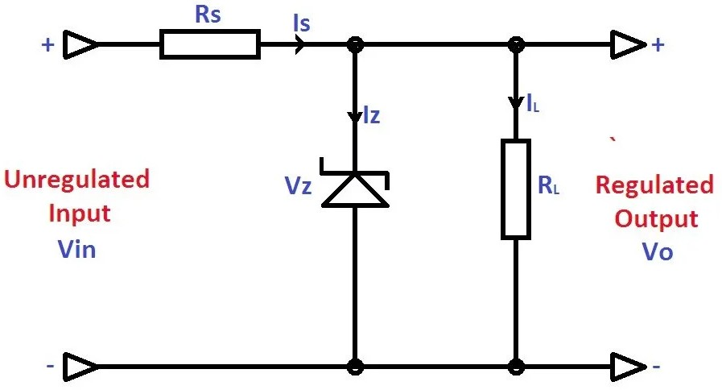

## Fig.3.2 Zener Diode as a Voltage Regulator

In the above circuit diagram excess voltage (Vin – Vz) will drop across Rs thus by limiting the current through Zener. For the proper designing of the regulator we should know,

* + Unregulated Input Voltage Range
  + Required Output Voltage
  + Max Load Current Required

The value of resistance Rs should satisfy the following conditions,

* + The value of Rs must be small enough to keep the Zener Diode in reverse breakdown region. The minimum current required for a Zener Diode to keep it in reverse breakdown region will be given in its datasheet. For example, a 5.6 V, 0.5 W zener diode has a recommended reverse current of 5 mA. If the reverse current is less than this value, the output voltage Vo will be unregulated.
  + The value of Rs must be large enough that the current through the zener diode should not destroy it. That is the maximum power dissipation Pmax should be less than IzVz.

Thus we should find Rsmin and Rsmax. To find the value of Rsmin we should consider the extreme condition that Vin is minimum and load current is maximum.

(3.5)

(3.6)

(3.6)

(3.7)

To find the value of Rsmax we should consider the extreme condition that Vin is maximum and load current is minimum (ie, no load connected).

(3.8)

(3.9)

(3.10)

(3.11)

## Line regulation (Regulation with a varying input voltage):

It is defined as the change in regulated voltage with respect to variation in line voltage. In this, input voltage varies but load resistance remains constant. As the input voltage increases, *Is* also increases accordingly as per Eq. (3.3). Therefore, Zener current *Iz* increases. The extra voltage is dropped across the *Rs*. Though *Iz* increases, *Vz* remains constant and *Vz* is equal to *Vout* and hence output voltage remains constant. If *Vin* decreases, *Iz* decreases. As load current remains constant, voltage drop across *Rs* reduces. But even though *Iz* changes, *Vz* remains constant and hence output voltage remains constant.

Zener diode as voltage regulator with varying input voltage:

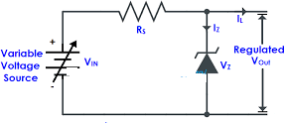

## Fig.3.3 Zener diode as voltage regulator

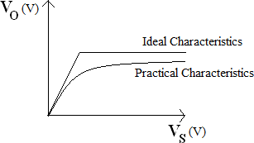

**Fig.3.4 Zener diode Line regulator**

**Load regulation (Regulation with the varying load):**

It is defined as change in load voltage with respect to variations in load current. To calculate this regulation, input voltage is kept constant and output load current is varied by changing the load resistance value. Consider output voltage is increased due to increase in the load current. The left side of the Eq. (3.4) is constant as input voltage *Vin*, *IS* and *Rs* is constant. Then as load current changes, the Zener current *Iz* will also change but in opposite way such that the sum of *Iz* and *IL* will remain constant, compensating the original increase or decrease in IL. Thus, if the load current increases, the Zener current decreases and sum remain constant. As per the reverse bias characteristics of Zener diode, though *Iz* changes, *Vz* remains same and hence output voltage remains fairly constant.

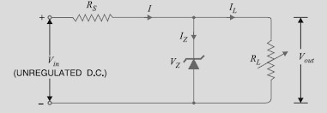

## Fig.3.5 Zener diode as voltage regulator

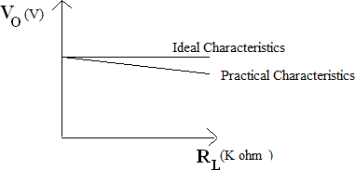

**Fig.3.6 Zener diode Load regulator**

**Procedure:**

1. **Line Regulation:**
   1. Make the connections as shown in the Fig. 3.3.
   2. Keep load resistance at fixed value; vary DC input voltage from 2V to 30V.
   3. Note down output voltages by varying DC input voltage from 2V to 30V.
   4. Calculate percentage line regulation by,

% Line Regulation = *(∆Vo/∆Vin)* ×*100* (3.12) Here*, Vo* is output voltage, *Vin* is input voltage, *∆Vo* is the change in output voltage for a particular change in input voltage *∆Vin*.

## Load Regulation:

* 1. For finding load regulation, make connections as shown in the Fig. 3.5.
  2. Keep input voltage constant say 10V and vary load resistance value.
  3. Note down output voltages for various values of load resistance including no load voltage *VNL* for maximum load resistance value and full load voltage *VFL* for minimum load resistance value.
  4. Calculate load regulation by % Load regulation =*V*(*NL*-*VFL*)/ *VFL* x100 (3.13)

# Observation Table:

**Line regulation:** RL = Constant

|  |  |  |
| --- | --- | --- |
| **Sr. No** | ***Vin*** | ***Vo*** |
| 1 | Vin1 =6.00 | Vo1 =5.07 |
| 2 | Vin2 =6.25 | Vo2 =5.17 |
| 3 | Vin3 =6.50 | Vo3 =5.24 |
| 4 | Vin4 =7.00 | Vo4 =5.35 |
| 5 | Vin5 =7.50 | Vo5 =5.46 |
| 6 | Vin6 =8.00 | Vo6 =5.56 |

## Load regulation:

*Vin* = Constant = …15… V with *VIN > VZ*

|  |  |  |  |
| --- | --- | --- | --- |
| **Sr. No** | ***IL* (mA)** | ***Vo* (V)** | ***RL* (Ω)** |
| 1 | IL1 =44.6 | Vo1 =5.13 | 115 |
| 2 | IL2 =44.4 | Vo2 =5.15 | 116 |
| 3 | IL3 =44.2 | Vo3 =5.17 | 117 |
| 4 | IL4 =44.9 | Vo4 =5.18 | 118 |
| 5 | IL5 =44.7 | Vo5 =5.20 | 119 |

## Note: Students are instructed to do all the necessary calculations on separate sheets.

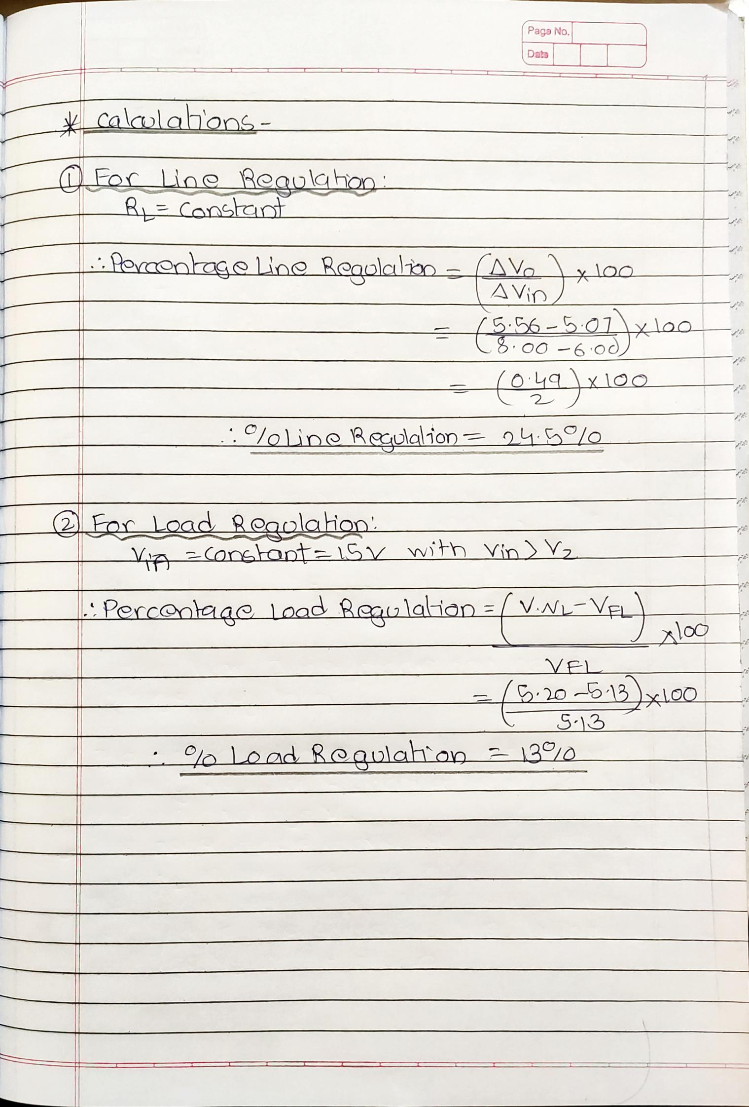

**Line Regulation:**

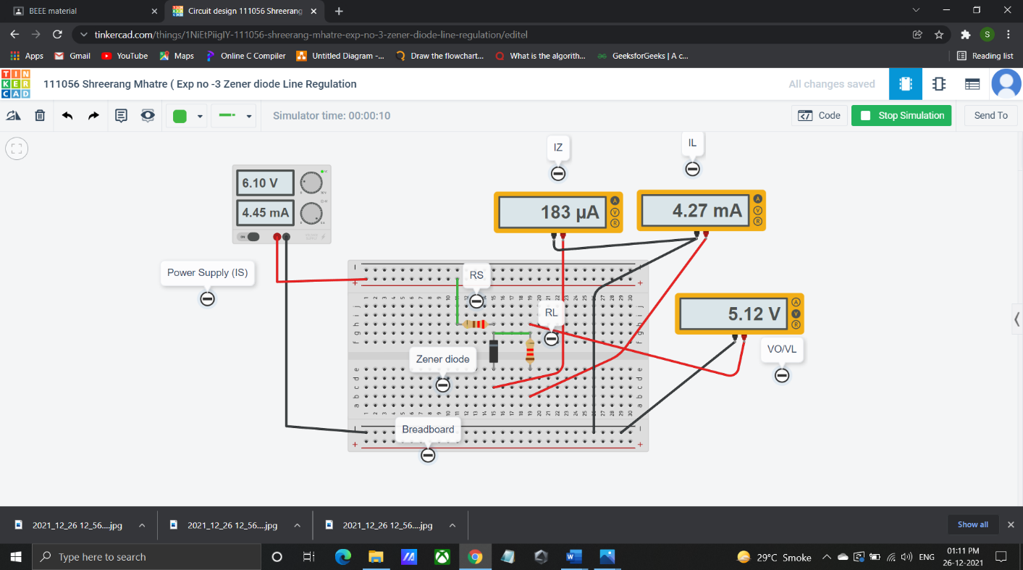

**Load Regulation:**

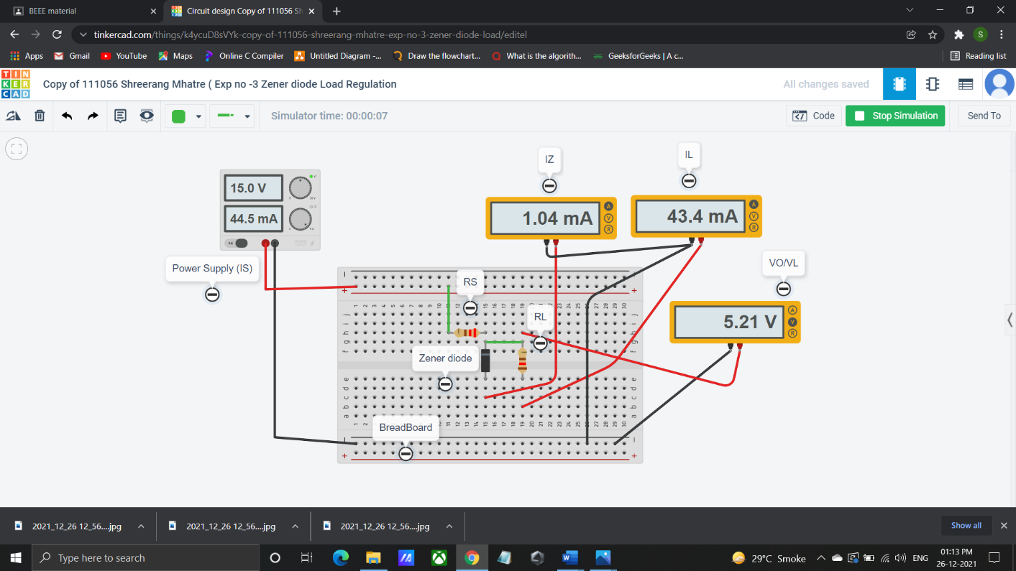

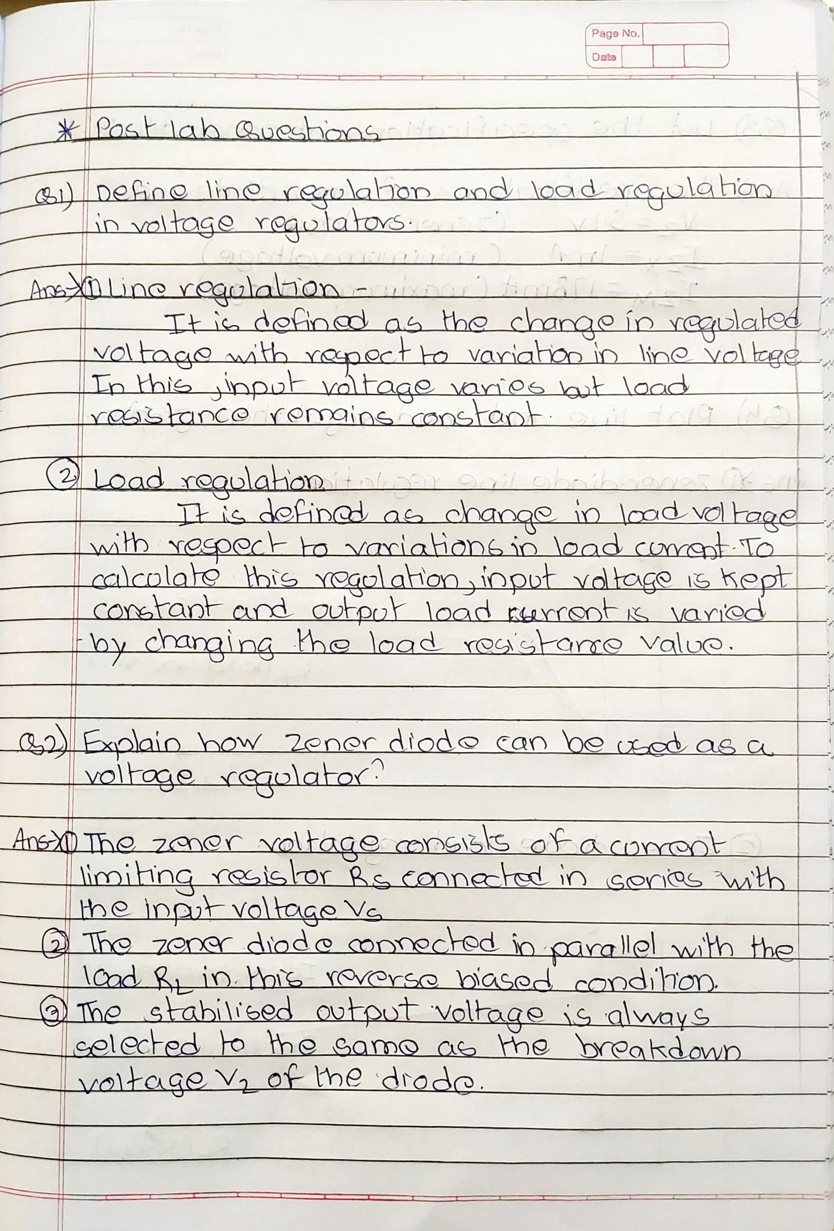

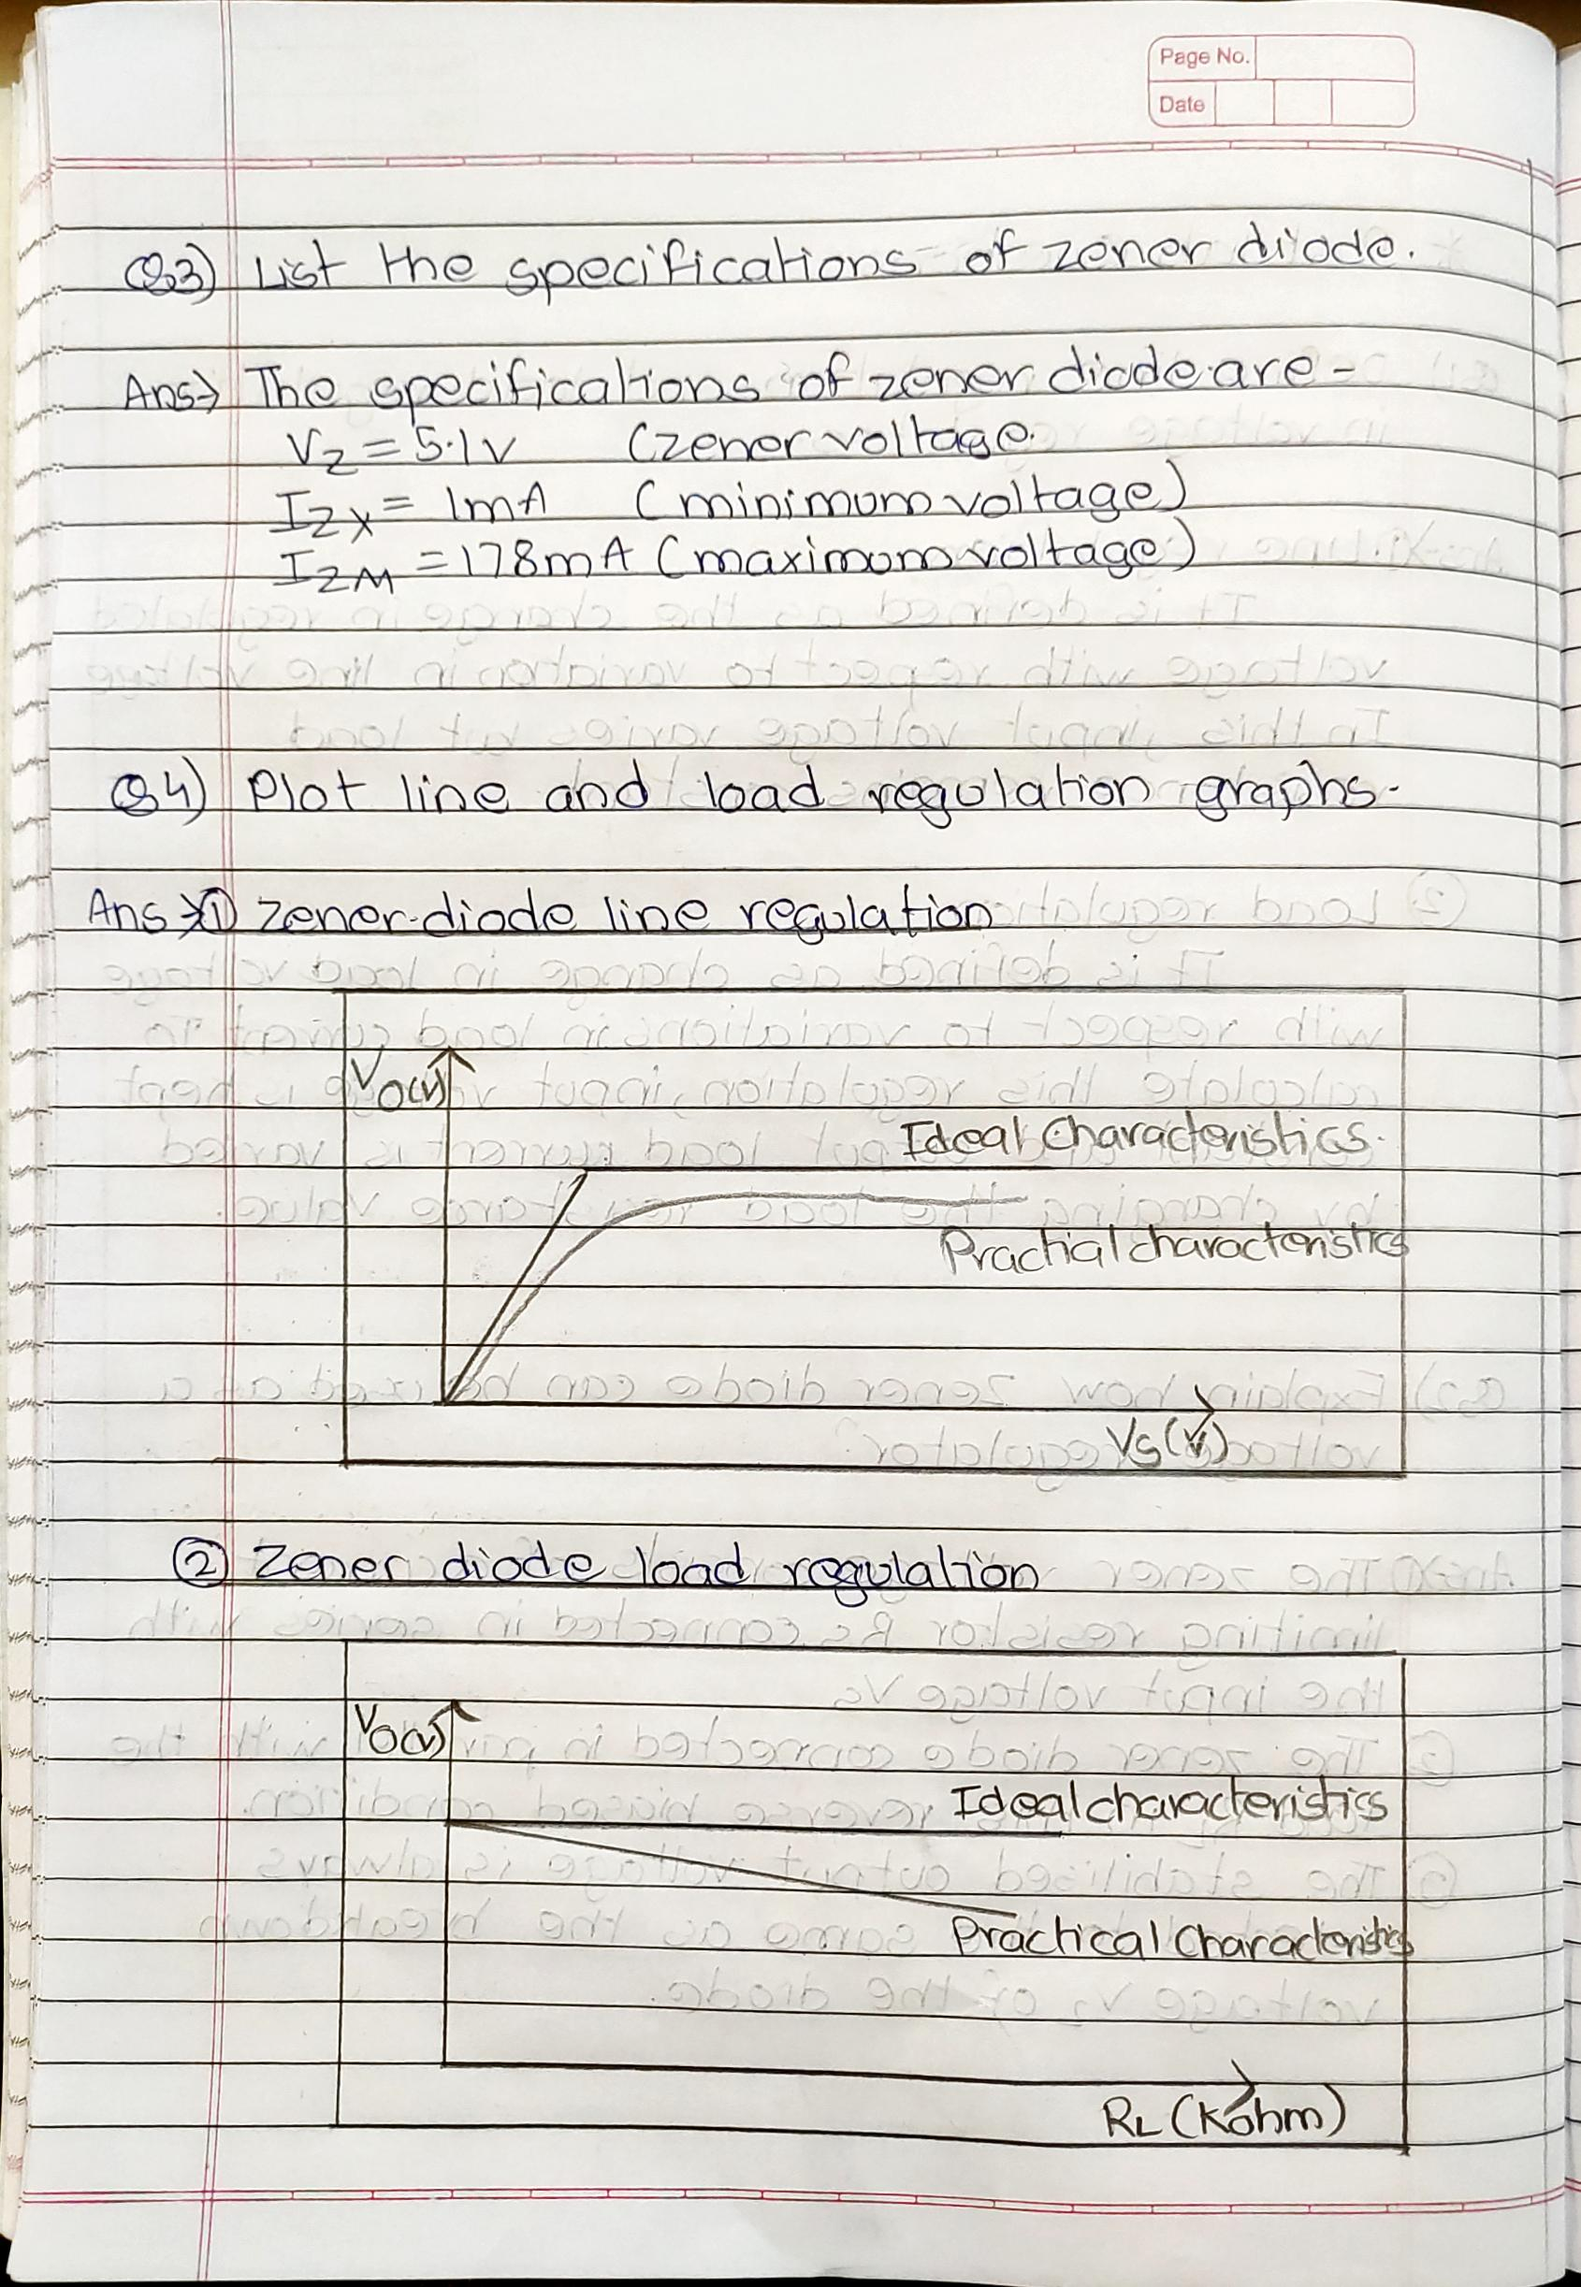

**Conclusion:**

From the above experiment we have learned about the Zener diode and its application .We have also learned about the Line and Load Regulation of Zener diode which acts as a regulator and understanding the concepts of Zener breakdown and Avalanche breakdown .We also have calculated the percentage Line and Load Regulation.

**Post Lab Questions:**

1. Define line regulation and load regulation in voltage regulators.
2. Explain how Zener diode can be used as a voltage regulator?
3. List the specifications of Zener diode.
4. Plot line and load regulation graphs.

# Additional links for more information:

* + <https://www.youtube.com/watch?v=WdDFI1IRQds>
  + vlab.amrita.edu